ALIGNMENT ISSUES IN VIETNAMESE LANGUAGE

1. CSS issue.

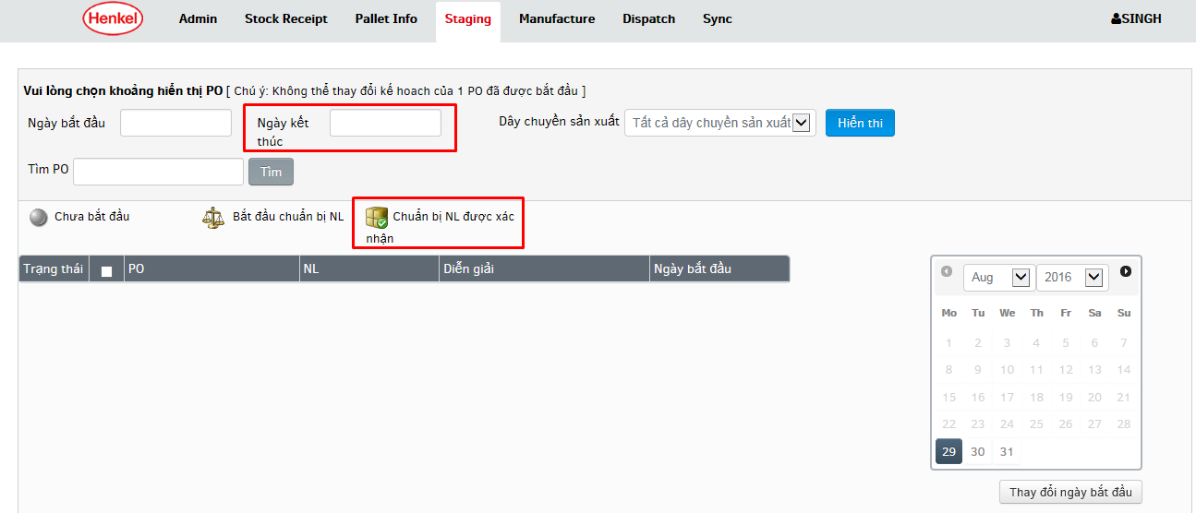

1. CSS issue

